- Please refer to our current website for the ideas https://www.encorb.com/marketplace.html, you can use the content from this website.
- Also, the website looks good but totally made up of AI try not to make it like that
- The platform is for USA, so please add all the images from USA like his image try to use better images
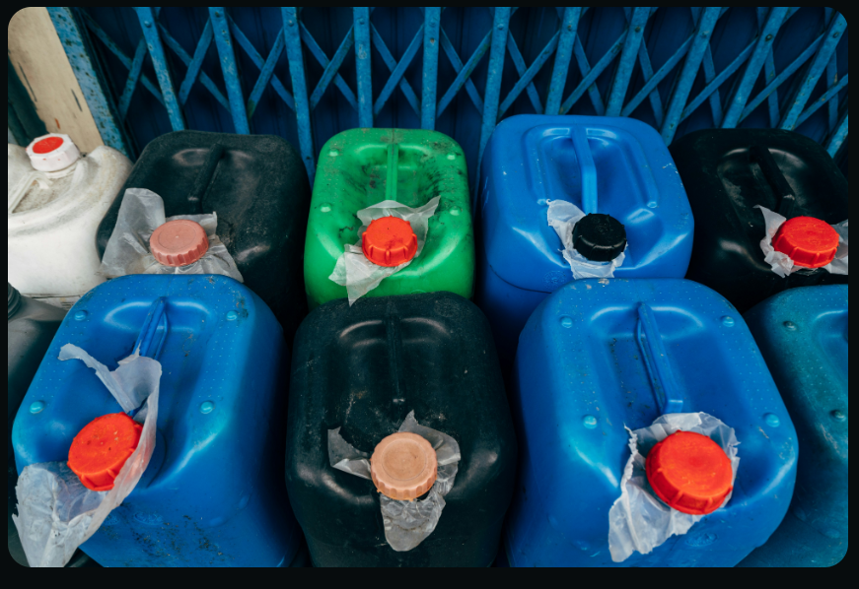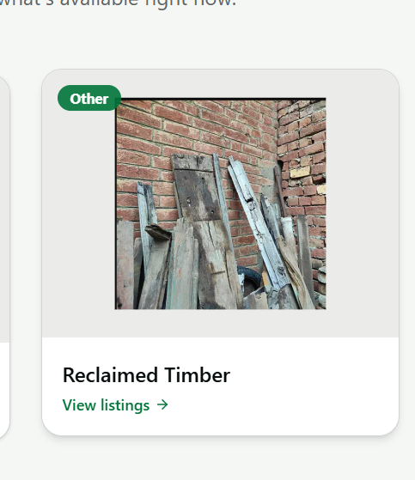
- See the references for the website we are envisionin - https://www.observe.ai/, recykal.com

